Summarize by type and taste

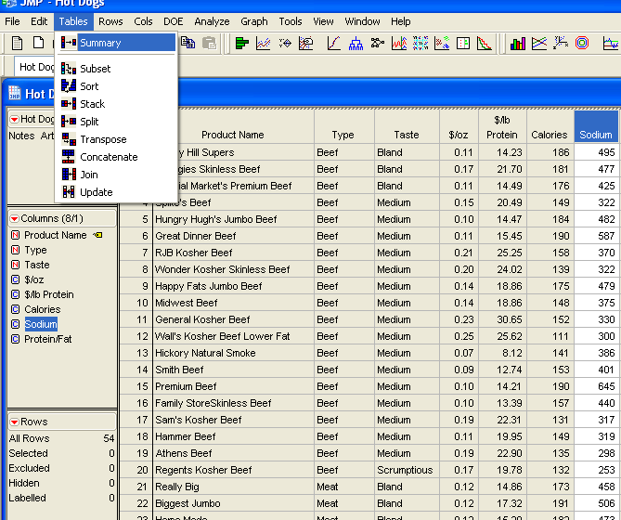

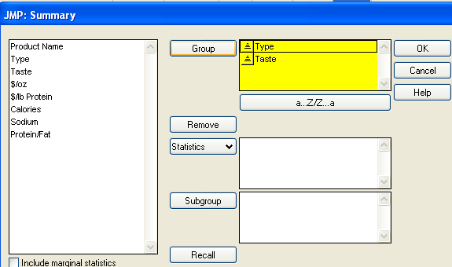

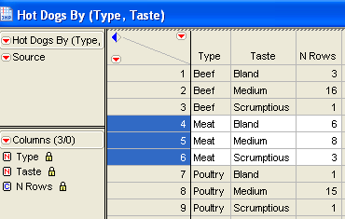

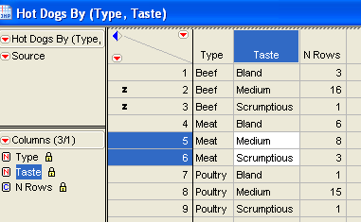

Shift-click or click and drag and drop the medium and scrumptious beef (rows 2,3)
Marker in Rows menu to assign them Z marker

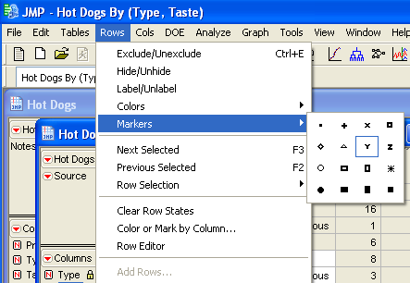

Do the same for Meat, poutry with marker Y and X

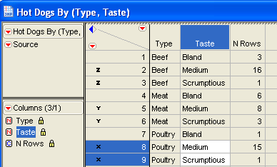

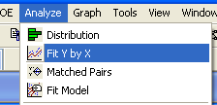

This produces $/lb Protein by $/oz and $lb Protein by Protein/fat

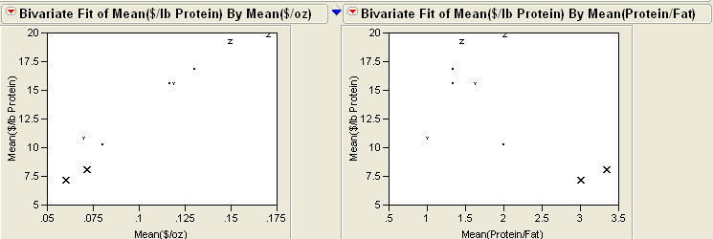

Select group by

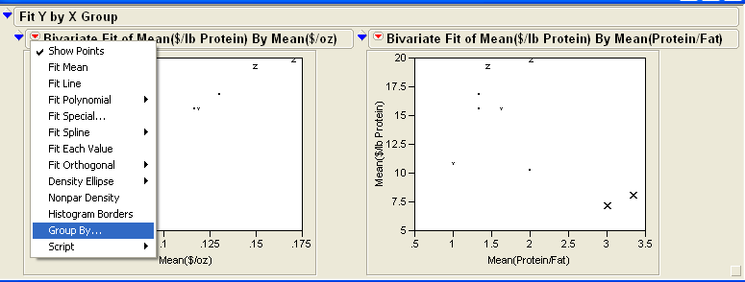

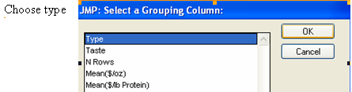

Do it for both, then select density 0.90 for both
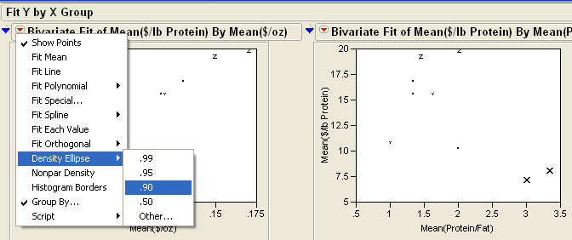

We are generating 2 graphs by 3 types of hot dogs: Meat, beef, poultry
We want to check the correlation for each type and if there are a similar behavior between types

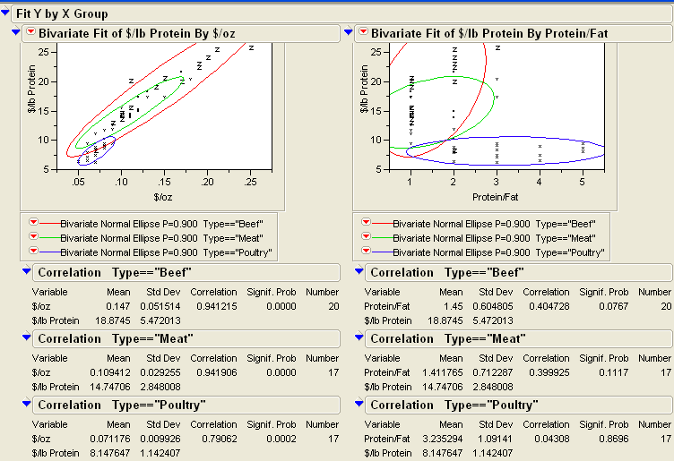

The 0.90 ellipses in the scatterplots show the shape of the bivariate response for each type of hot dog . The special markers identify the taste and type for each point

First graph:
- Correlation has a significant lower than 0.01 , so we are almost 100% confident
- The correlation between $/lb and $/oz is high 0.94 0.94 and 0.79
- As it grows the $lb protein it increases also $oz which makes sense
- The 3 types of hot dogs (beef, meat, poultry) have the same behavior
- However the range in poultry is shorter, its data is concentrated, there isn’t data for higher cost

Second graph
- None of the variables are lower than 0.05 to make 95%, so they are not confident, these correlations cannot be taken in consideration
- Poutry (blue) increases in Protein/Fat and it stays in a low cost $lb Protein

Conclusion, the best graph shapes are in the first graph. a confident correlation

